# **Introduction to Data Communication and Computer Networks**

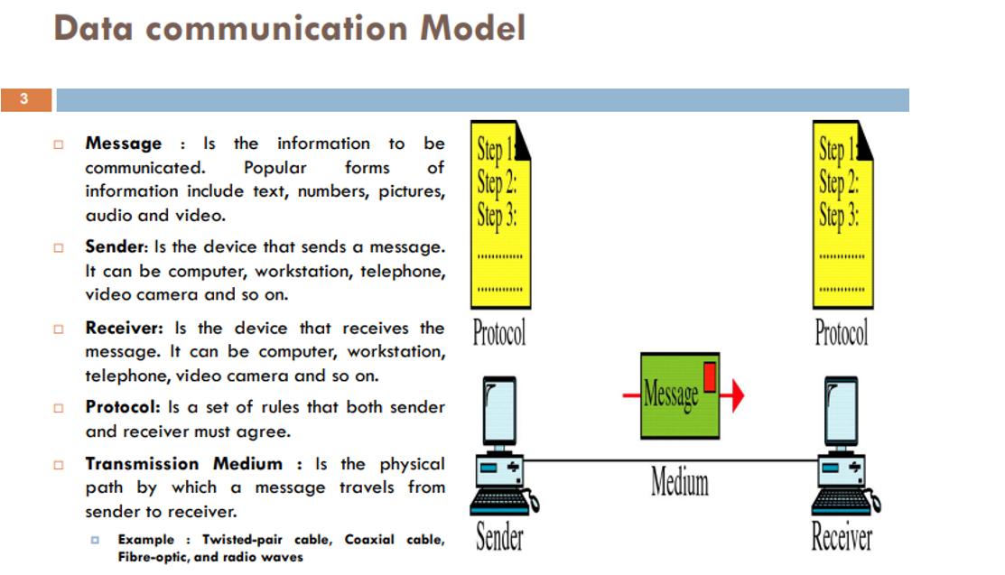

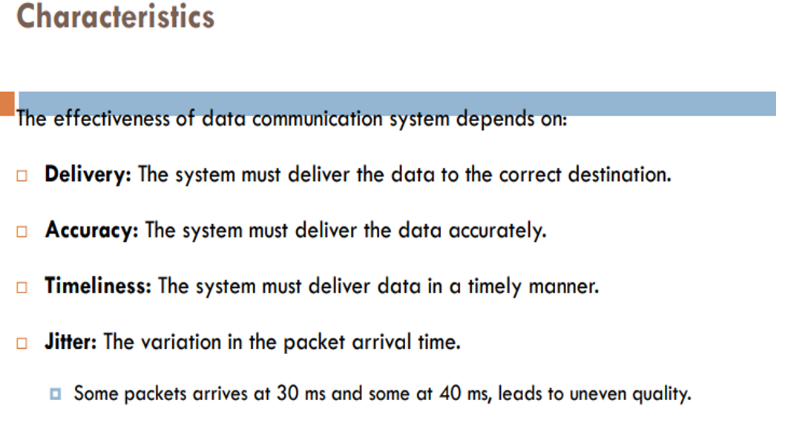

## **Network**

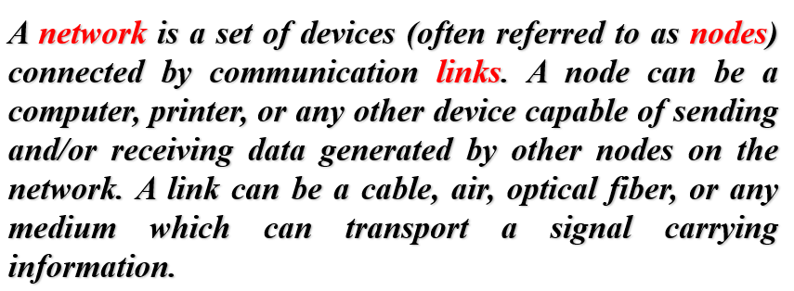

## **Network criteria**

1) Performance 2) Reliability 3) Security

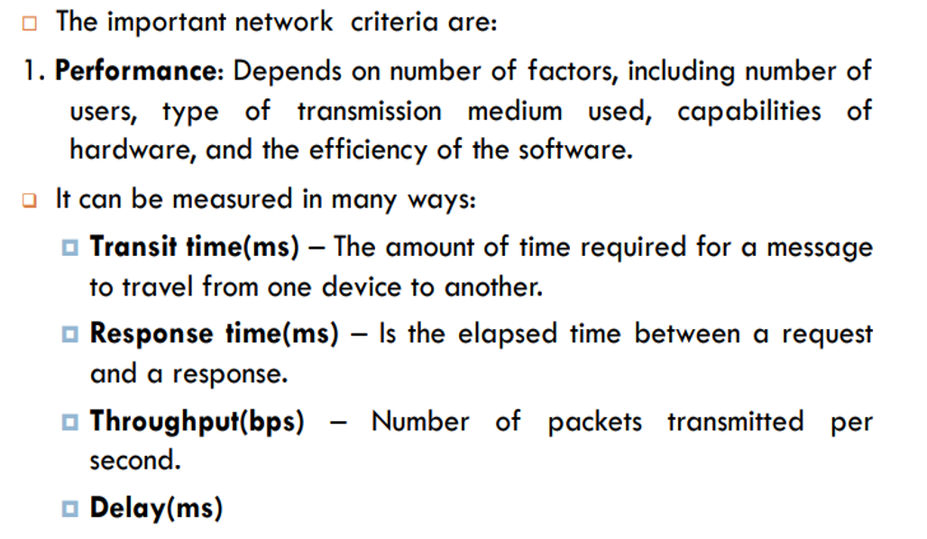  
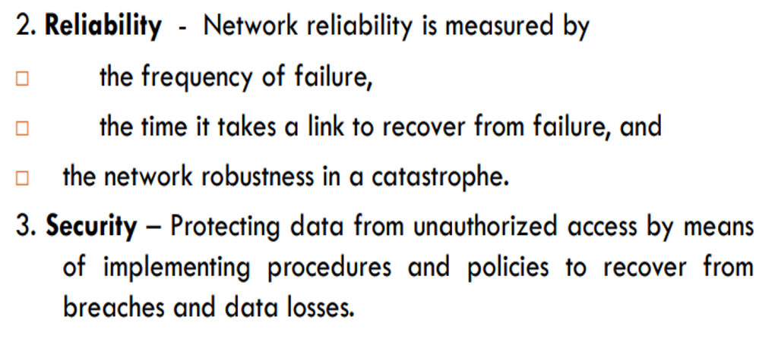

## **Transmission Mode**

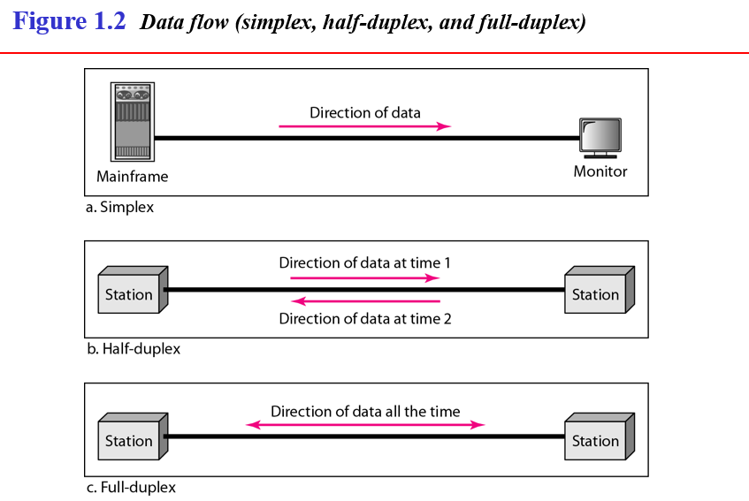

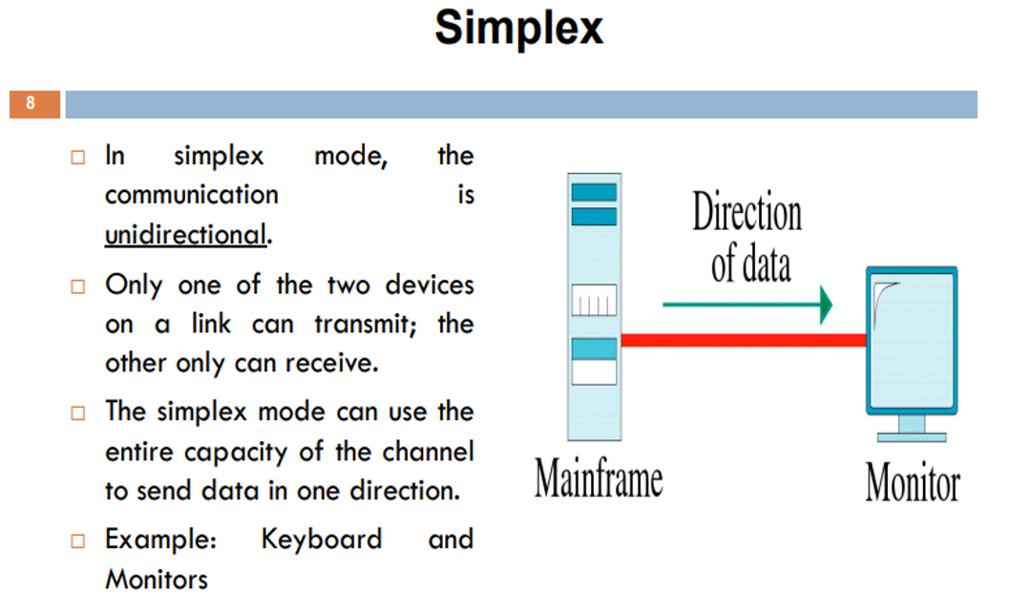



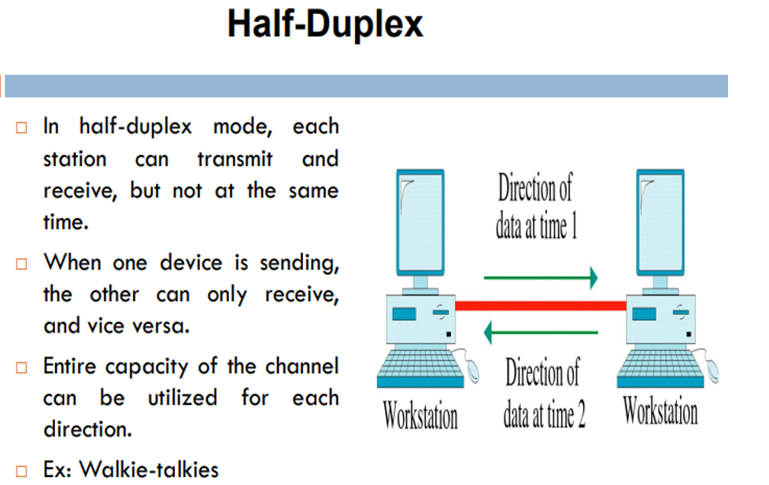



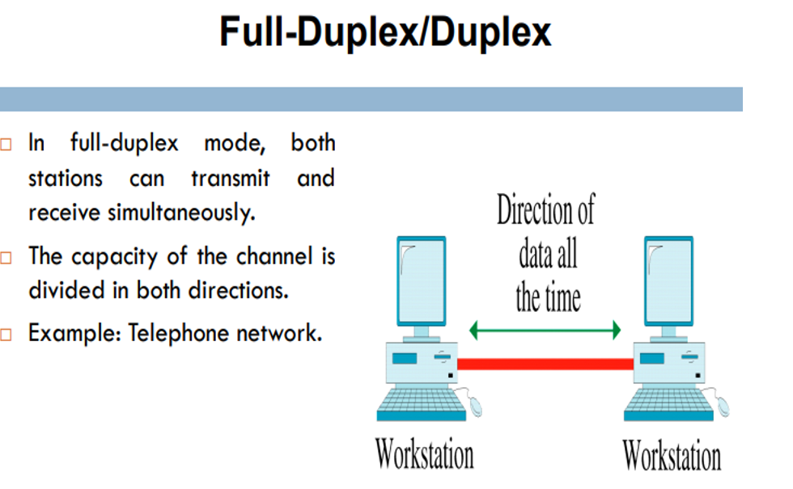



## **Physical Structures of Network**

**Connection**

**Point to point** **Multi-point**



single transmitter and a Multiple recipients of   
single receiver. single transmission.

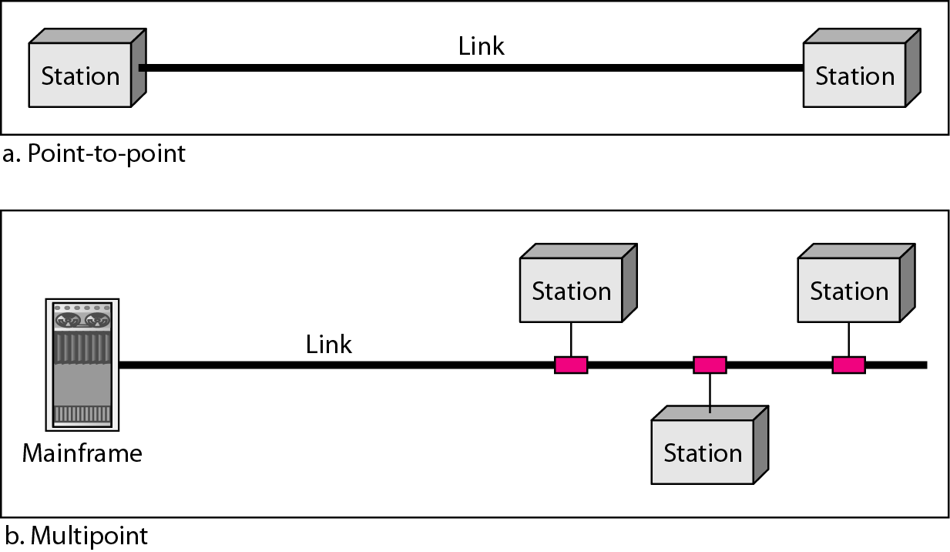

## **Network(city) Topology(road)**

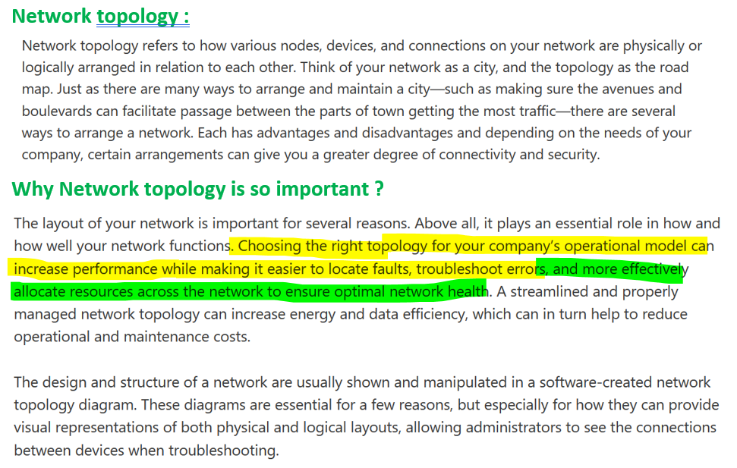

**Logical Network topology :**Logical network topology is a little more abstract and strategic, referring to the conceptual understanding of how and why the network is arranged the way it is, and how data moves through it. The logical network topology is a higher-level idea of how the network is set up, including which nodes connect to each other and in which ways, as well as how data is transmitted through the network. Logical network topology includes any virtual and cloud resources.

**Physical Network topology :**Physical network topology, as the name suggests, refers to the physical connections and interconnections between nodes and the network—the wires, cables, and so forth.The physical network topology refers to the actual connections (wires, cables, etc.) of how the network is arranged. Setup, maintenance, and provisioning tasks require insight into the physical network.

## **Types of Transmission in Physical Network Topology**

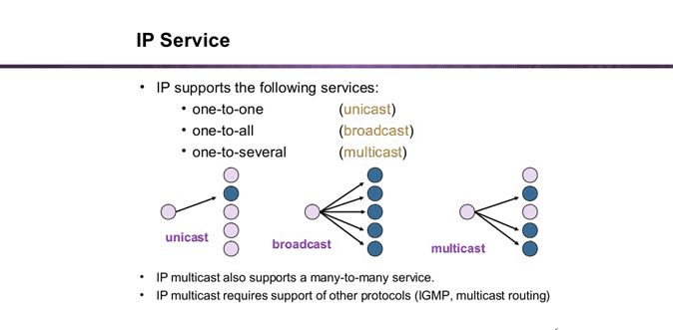

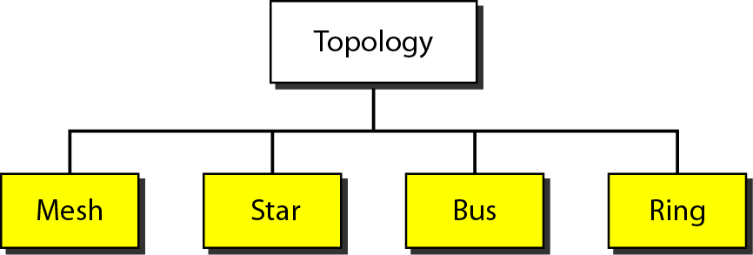

**Mesh topology**

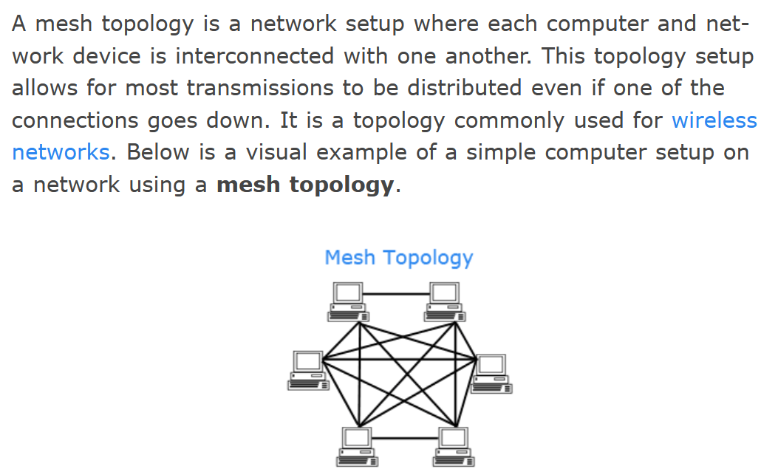

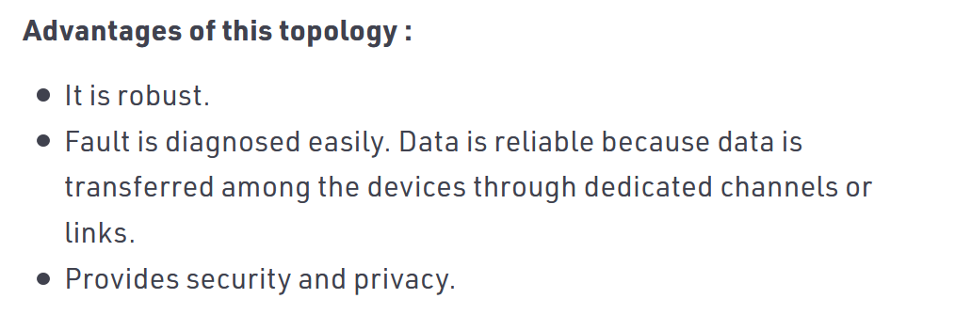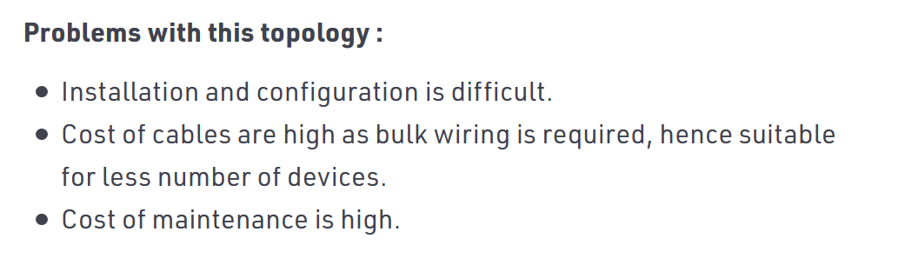

**Star topology**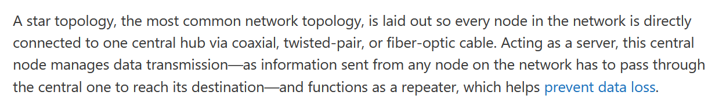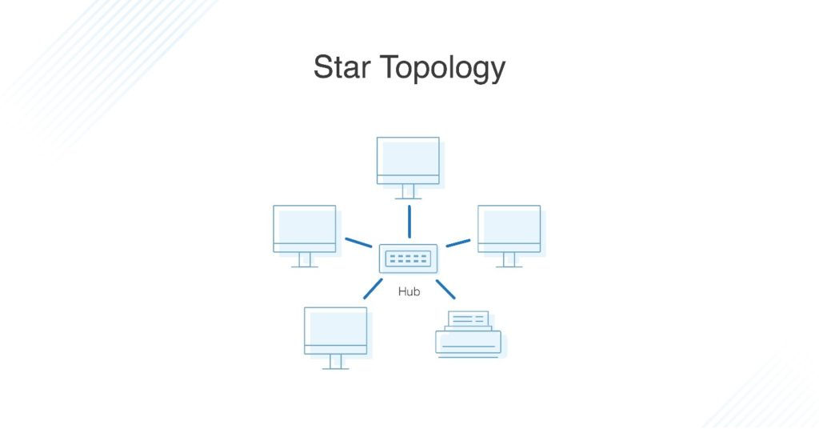

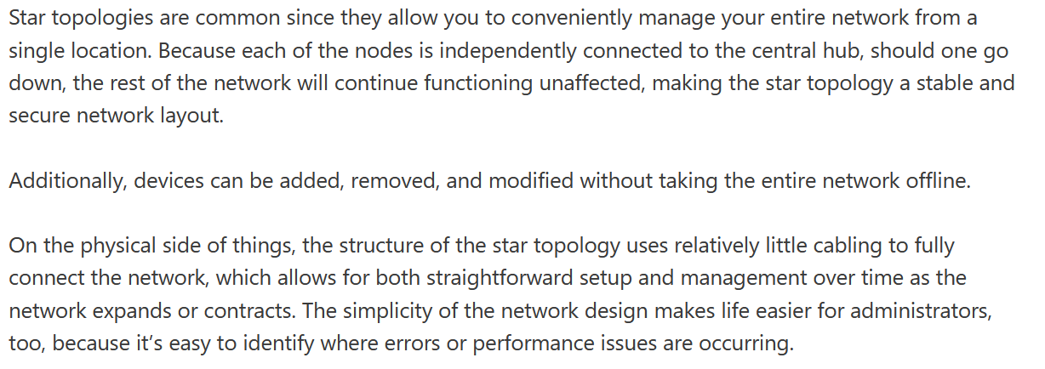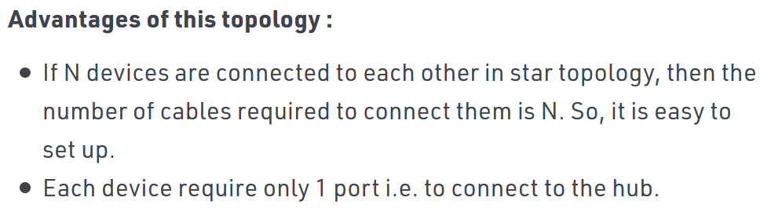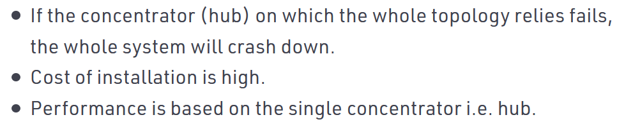

**Bus topology**

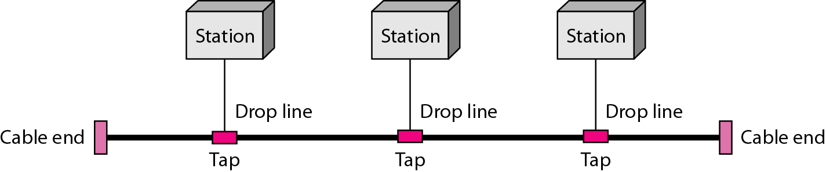

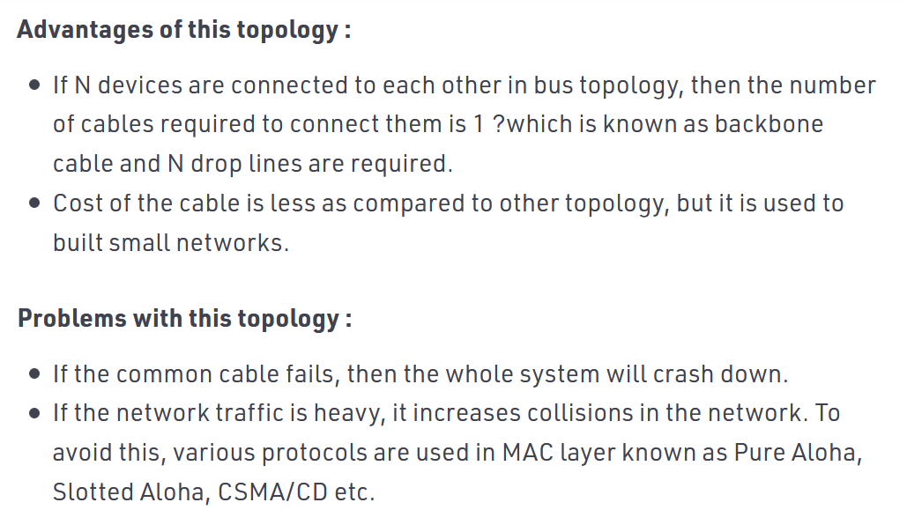

**Ring topology**

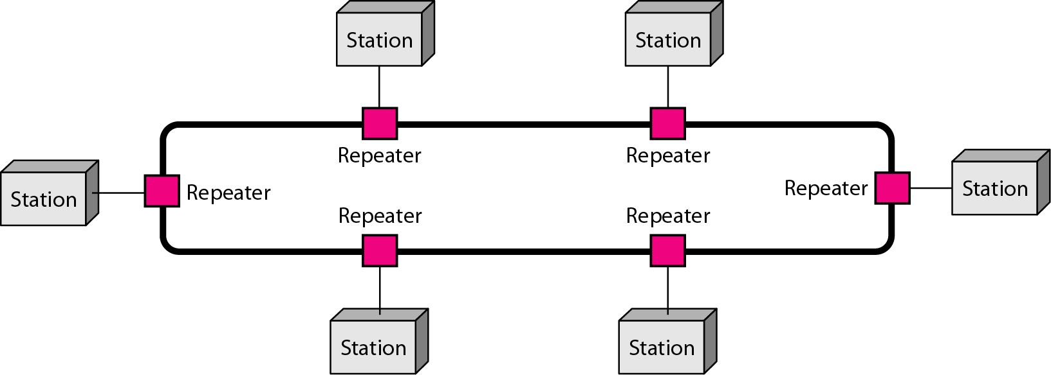



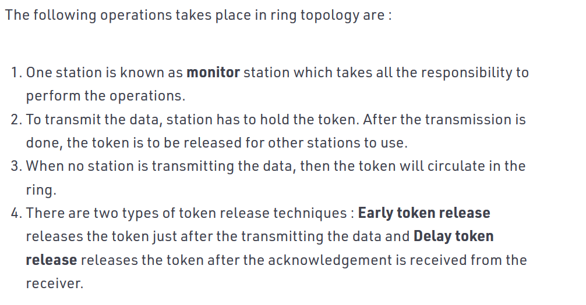

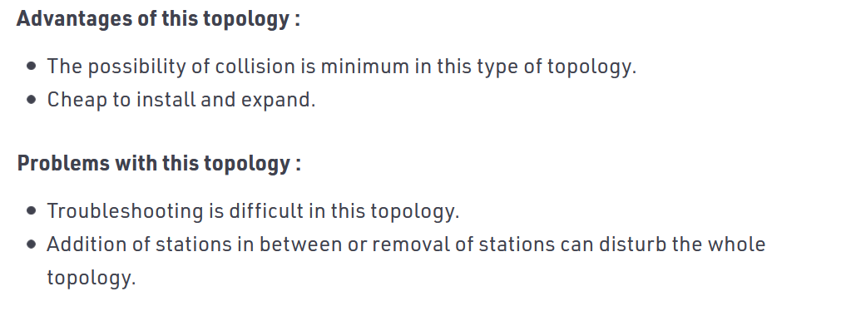

**Hybrid topology**

***a star backbone with three bus networks***

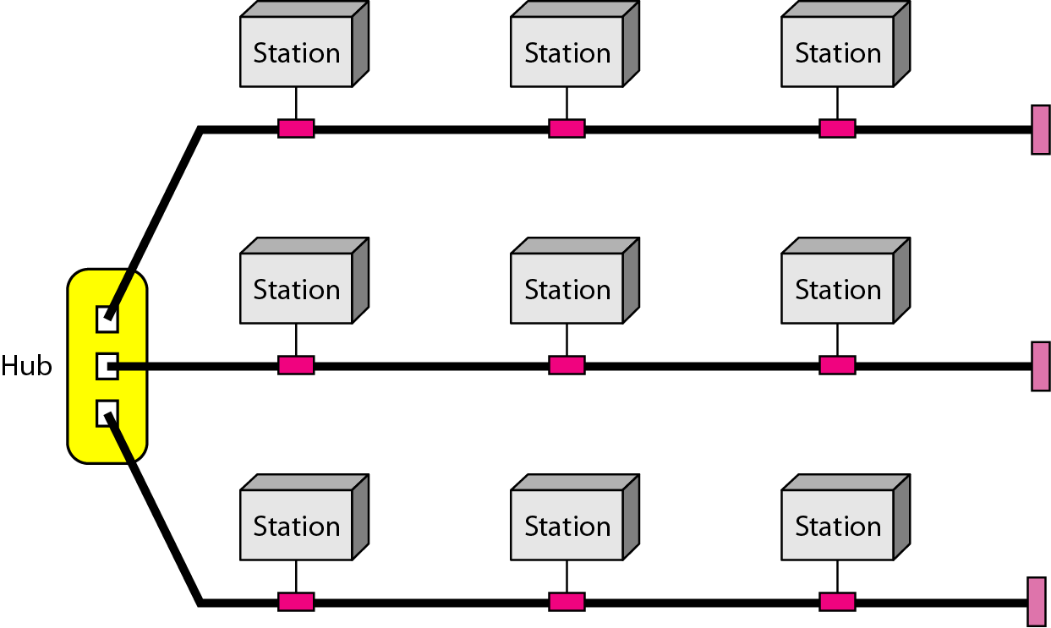

**Over-all Difference**

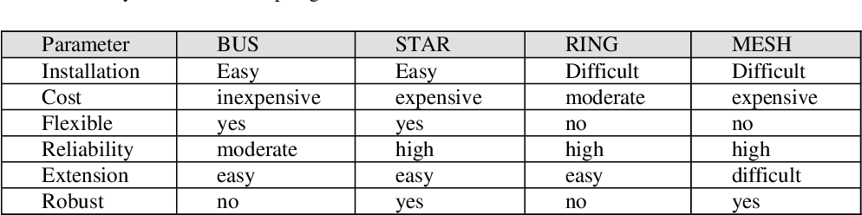

## **Categories of Network**

### **Local Area Network**

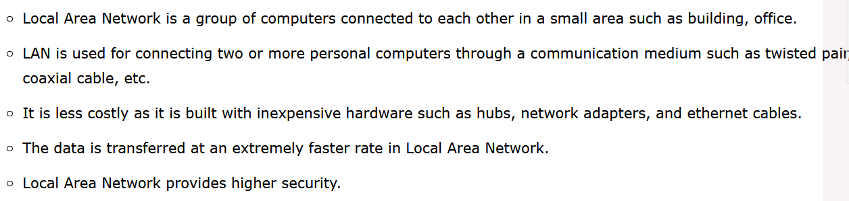

### **Metropolitan Area Network**

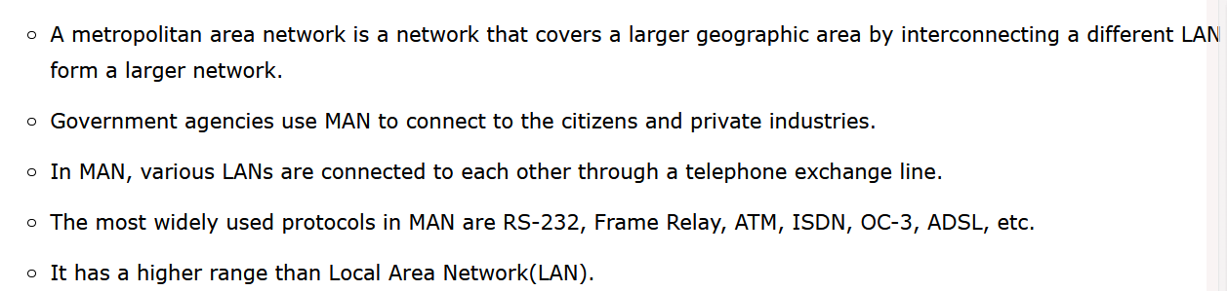

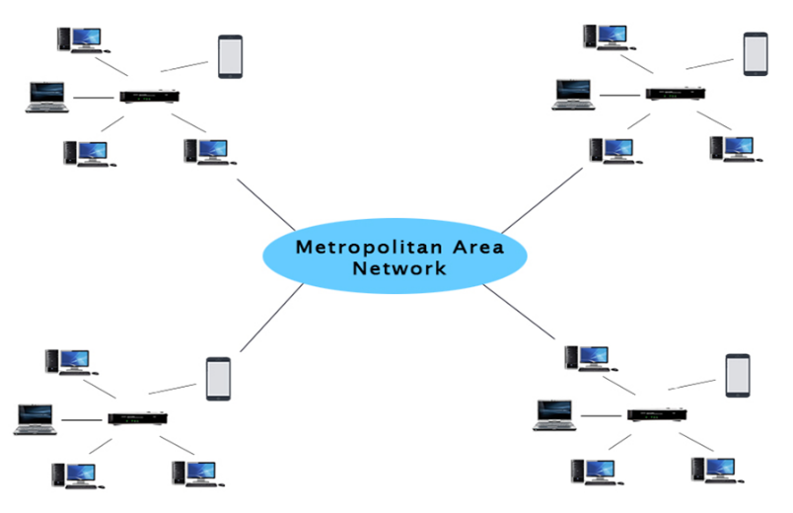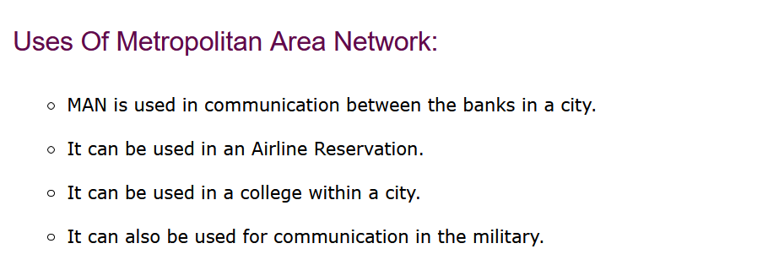

### **Wide Area Network**

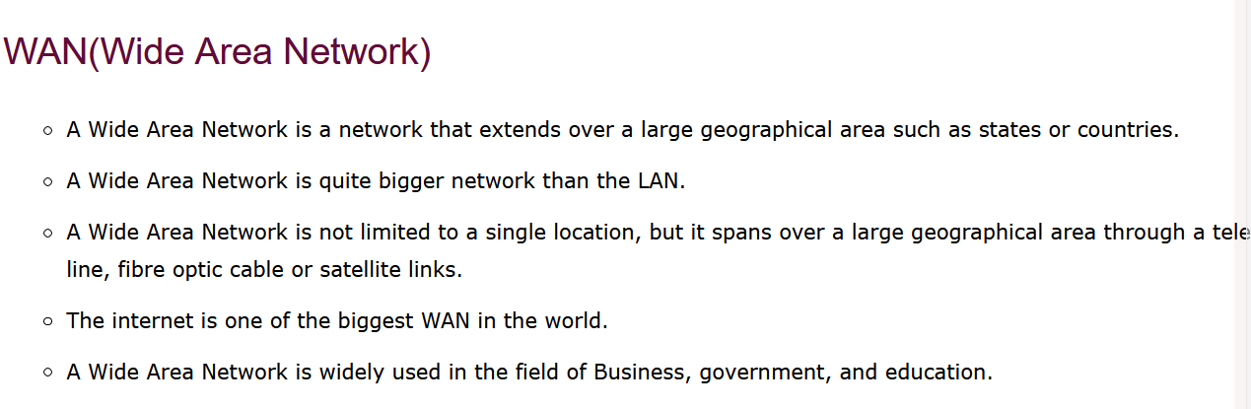

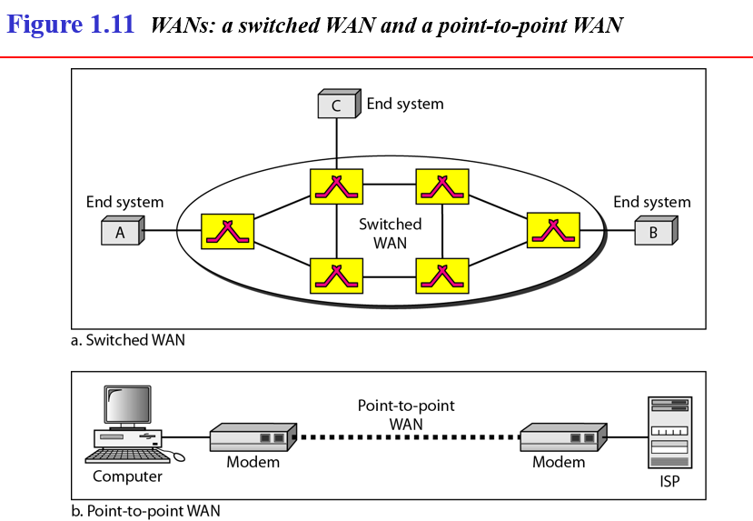

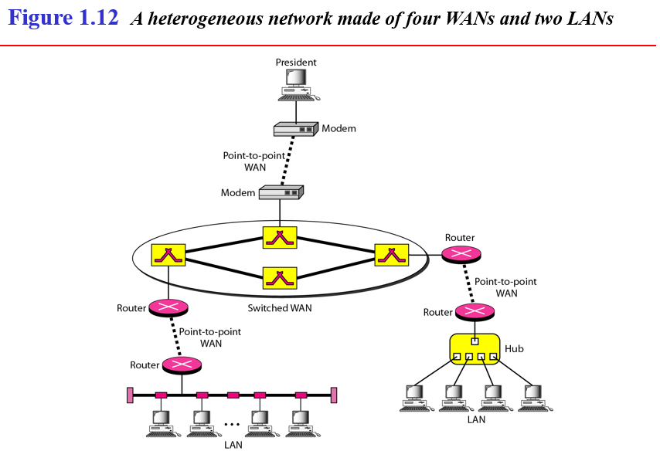

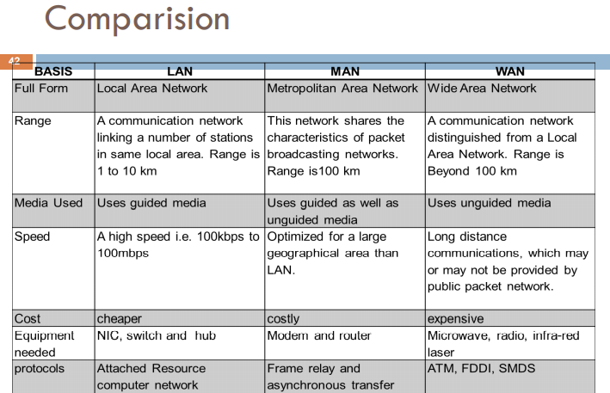

# **Protocols**

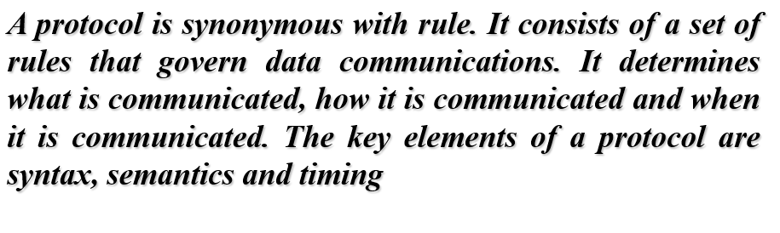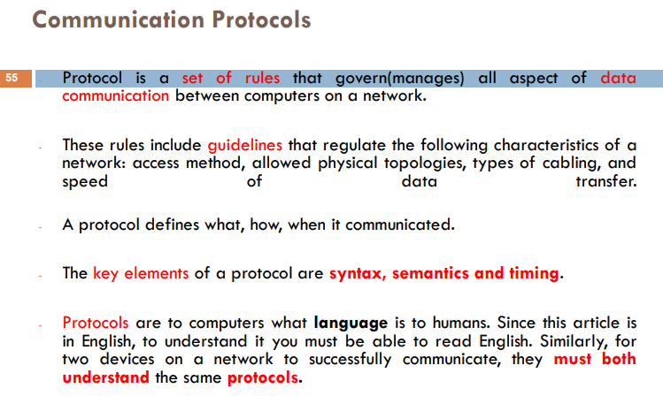

## **Elements of the Protocols**

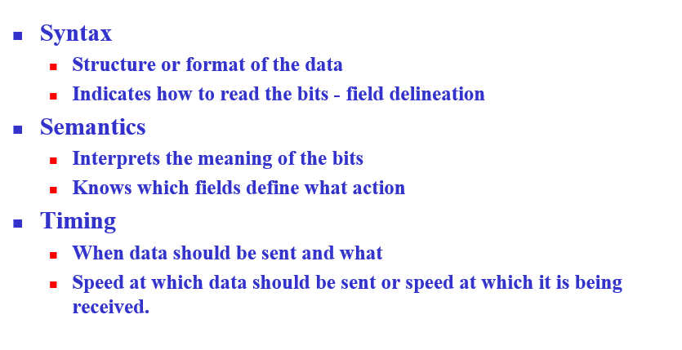

# **OSI Layer Protocols**

Open System Interconnection

## **Physical Layer**

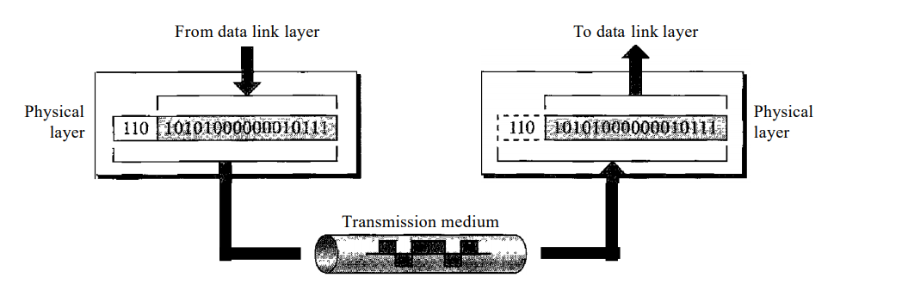

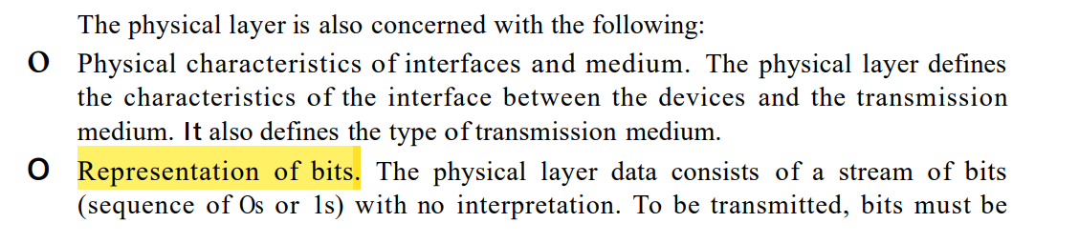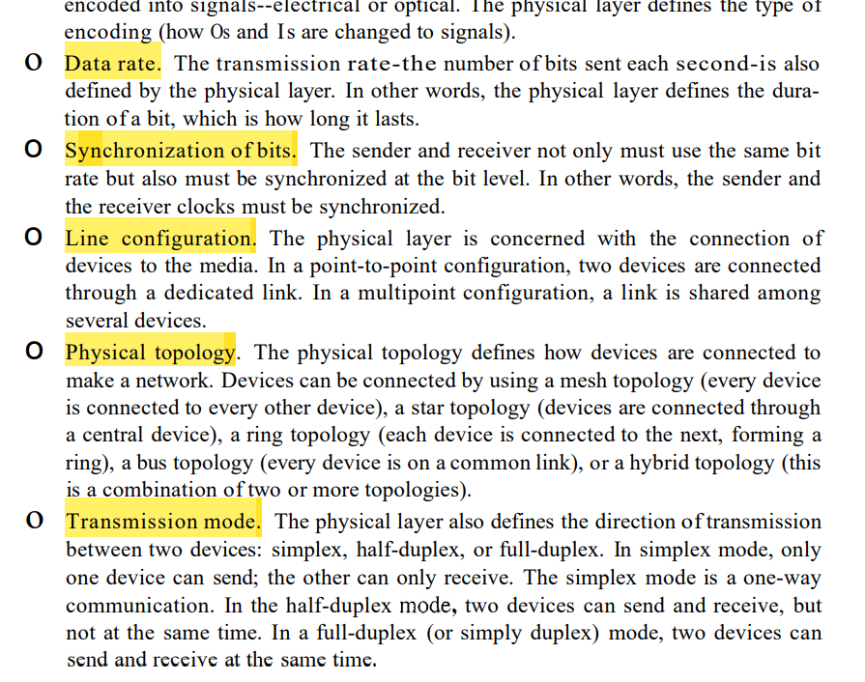

## **Data-Link Layer**

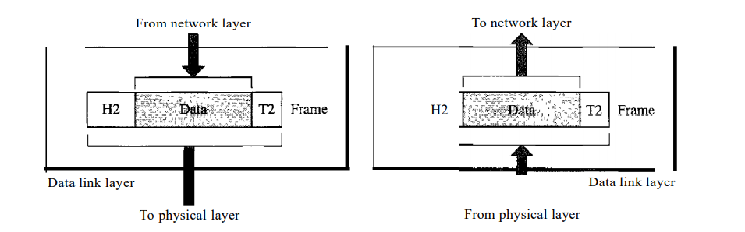

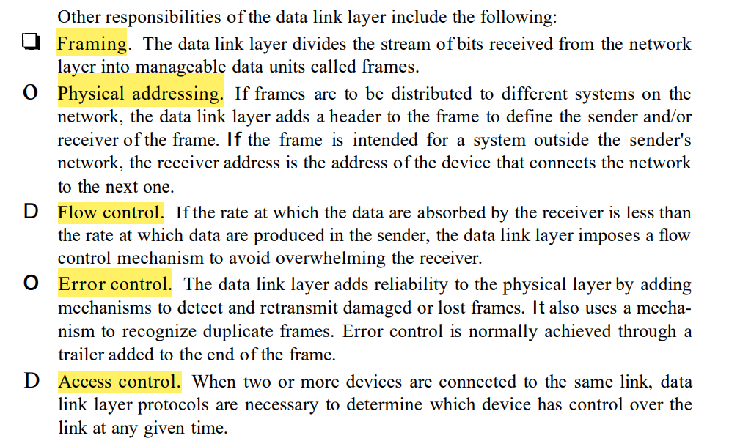

## **Network-Layer**

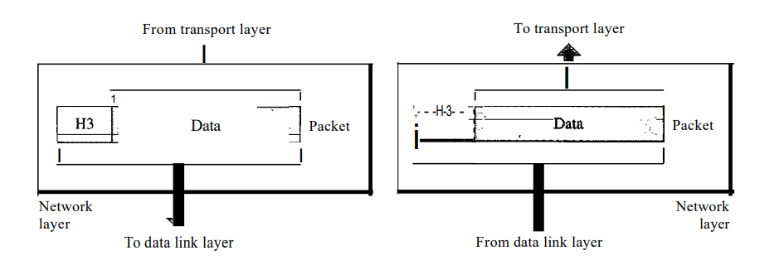

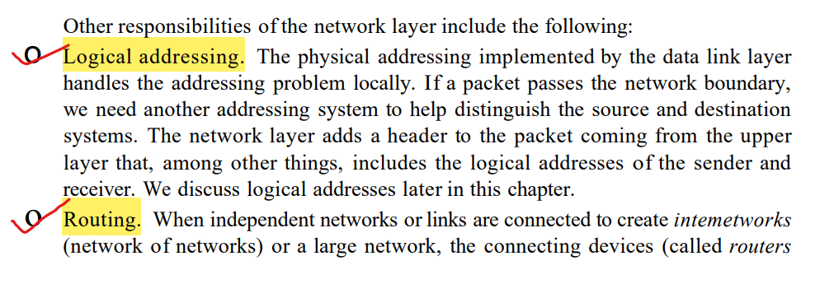  




## **Transport-Layer**

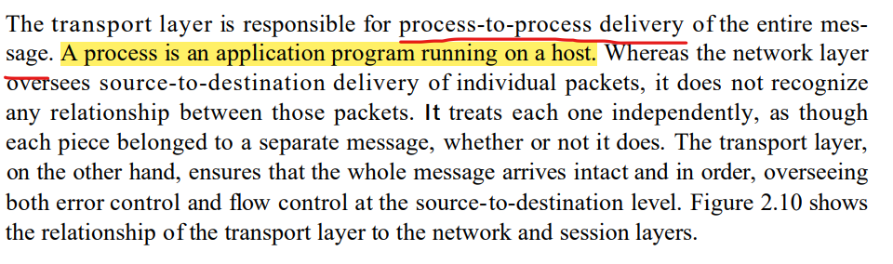

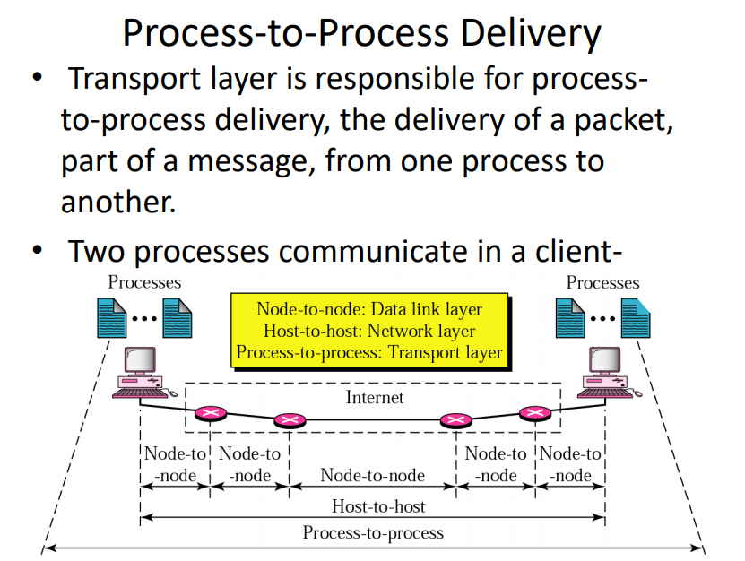

## **Session-Layer**

Starts, maintains and closes the sessions of the computer conversations and identifies it-self with the port numbers.

Functions performed by the session layer

* Authentication 🡪 With the help of user name and password. (Eg: A user logging into face-book website.)
* A user clicks for a image and text to view it.
* Authorization 🡪 After authentication, whether a particular user can access the data and files in the server. So the session layer checks whether that user is allowed to download the image and text. If allowed, then these image and text are sent to the client via data-packets.
* These data packets are rendered in the form of html page.
* The overall process is known as Session Management.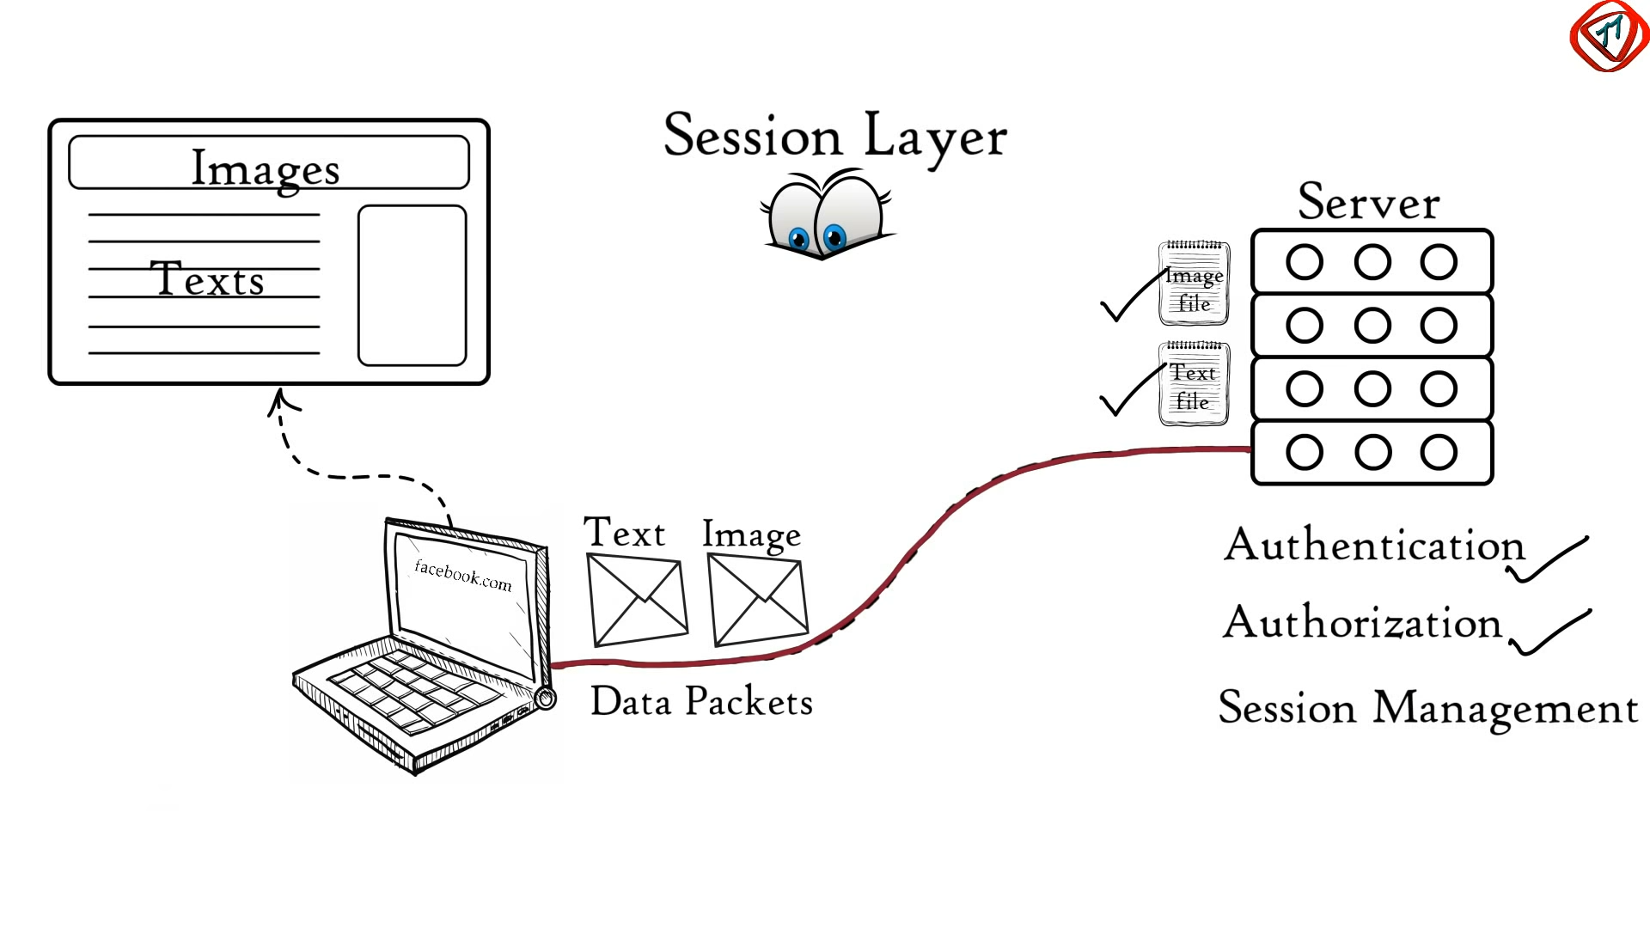

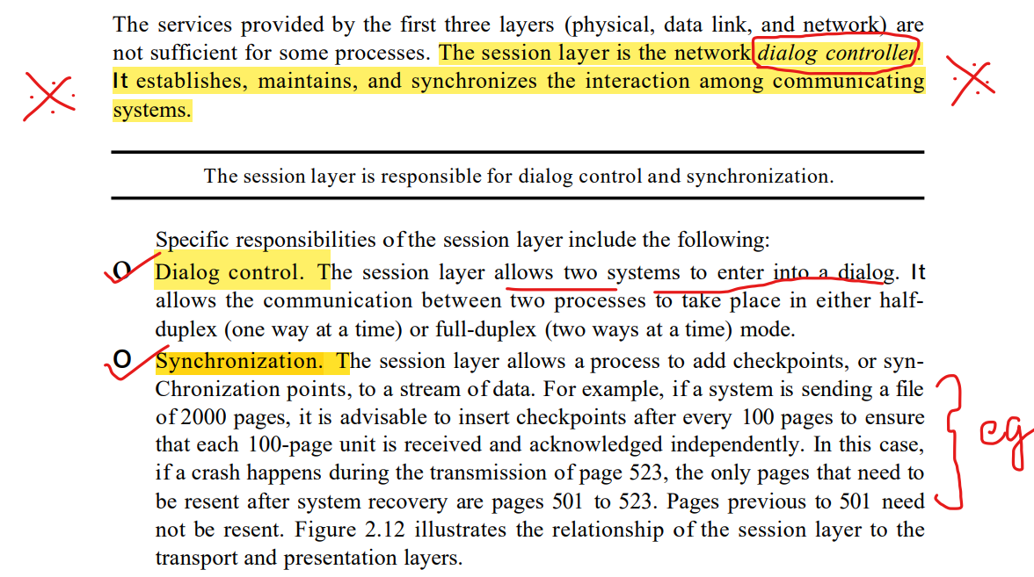

## **Presentation-Layer**

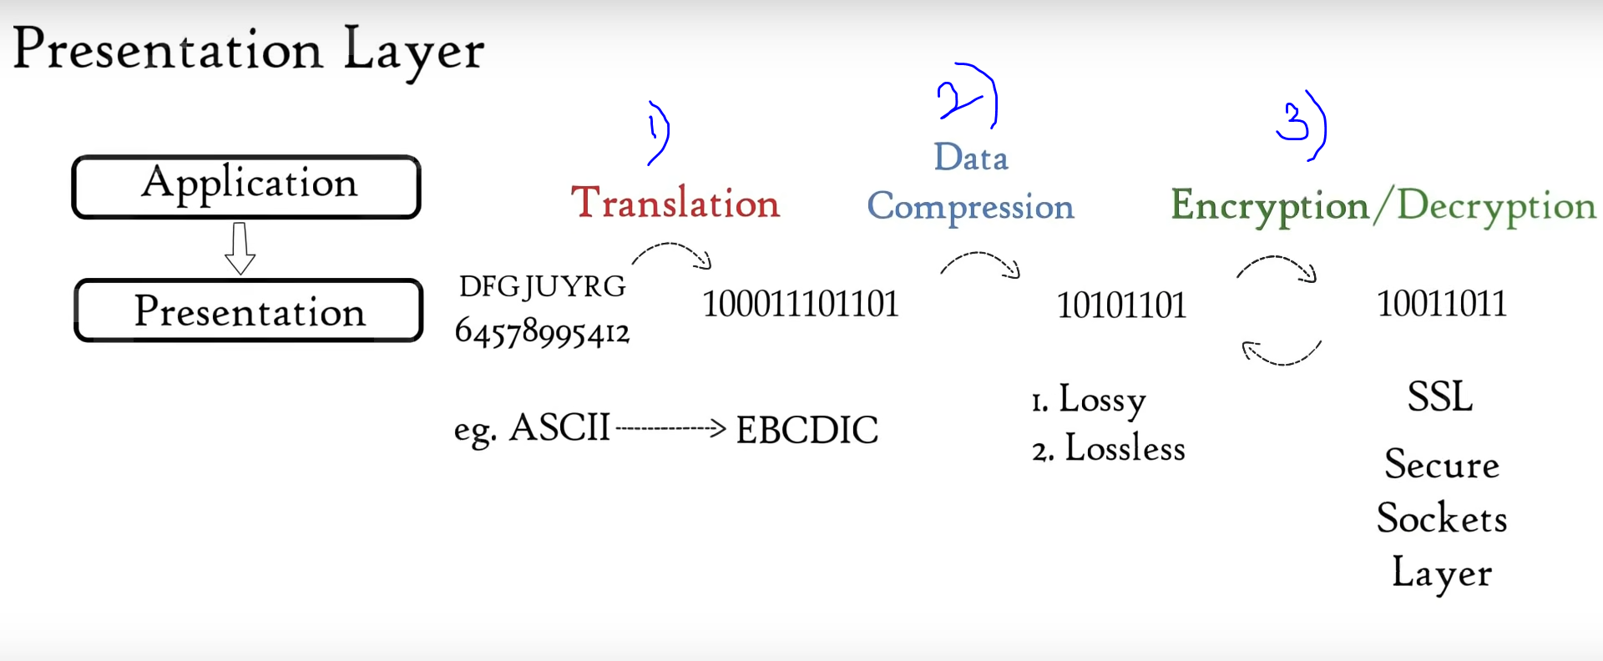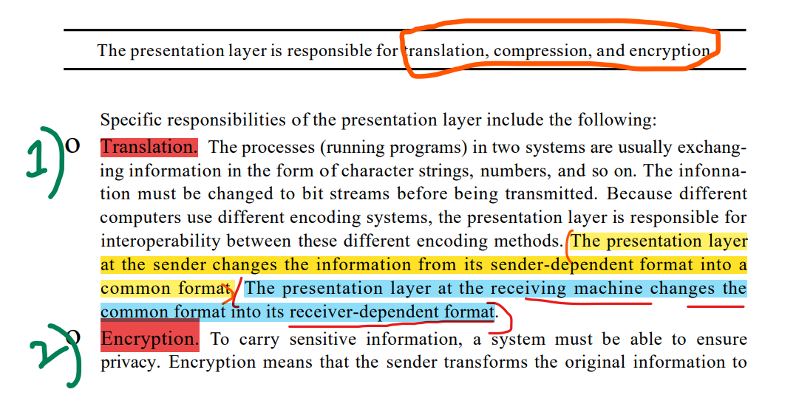

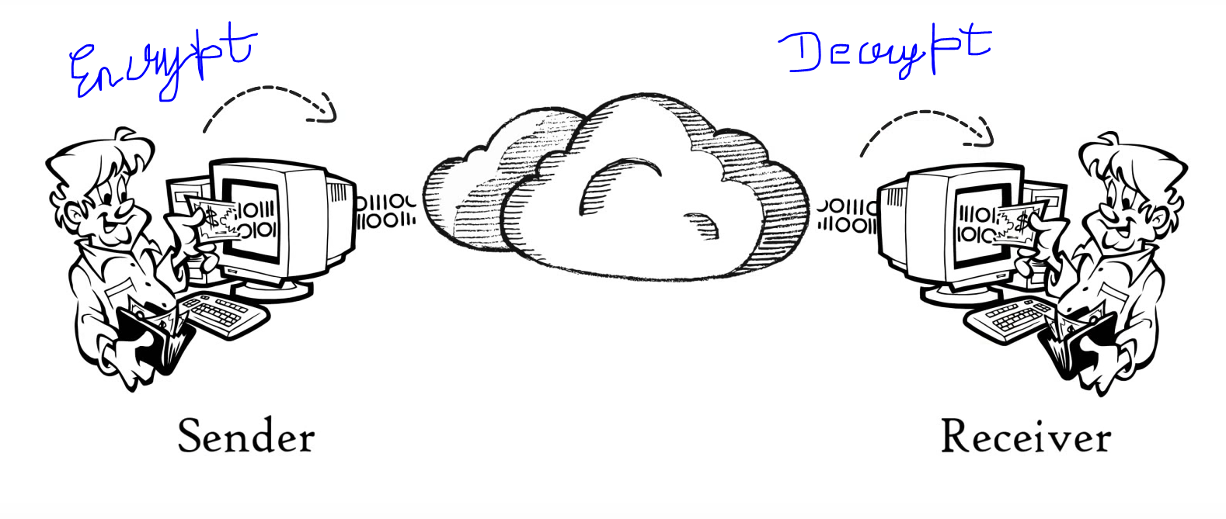

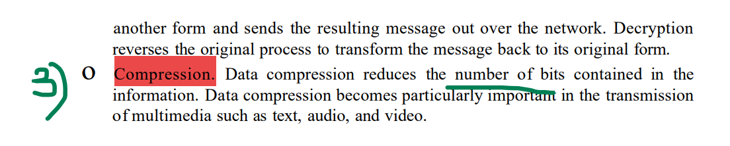

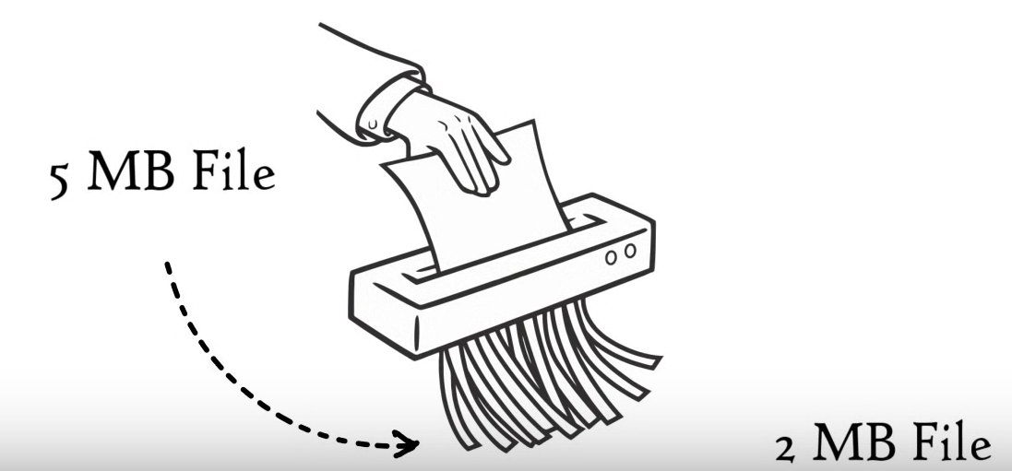

## **Application-Layer**

# Reference

<https://www.dnsstuff.com/what-is-network-topology#what-is-network-topology>

<https://www.esds.co.in/blog/difference-between-unicast-broadcast-and-multicast/#sthash.5UI4eCRc.dpbs>

https://www.tutorialspoint.com/data_communication_computer_network/error_detection_and_correction.htm